**Attachment 2**

1.1 Please open the Zoom desktop client.

If you don’t have an account, please click “sign-up” in the bottom right to visit the Zoom sign-up page.

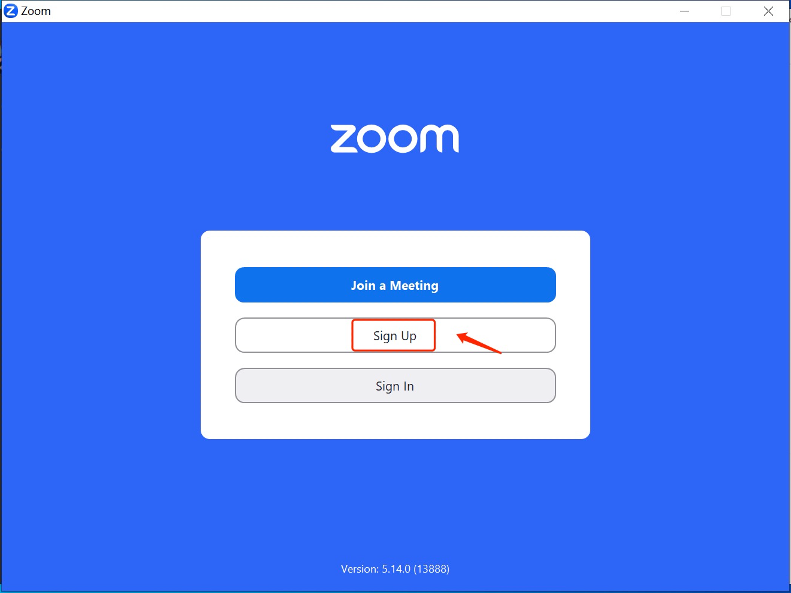

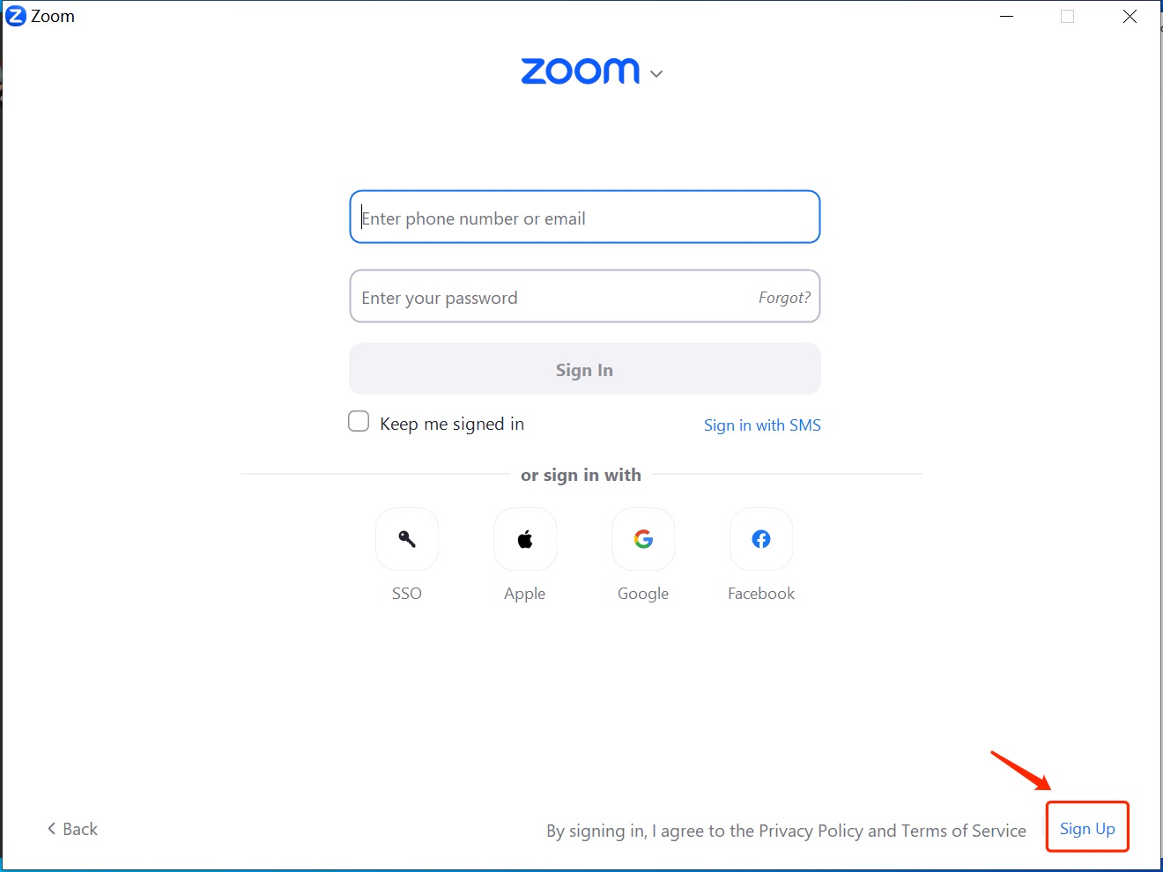

1.2 If the sign-up page doesn’t pop up automatically, please open the website ([www.zoom.us](http://www.zoom.us)) in your browser. Click “sign up free” in the top right.



1. Follow the prompts to fill in your information step by step.

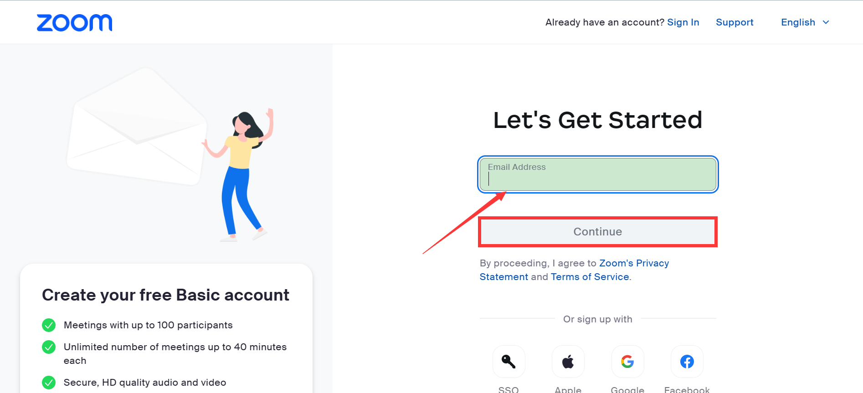

3. Once you succeed in sign-up, a page will show up your registration information.



4. Open the Zoom app/web client and click “sign in”.

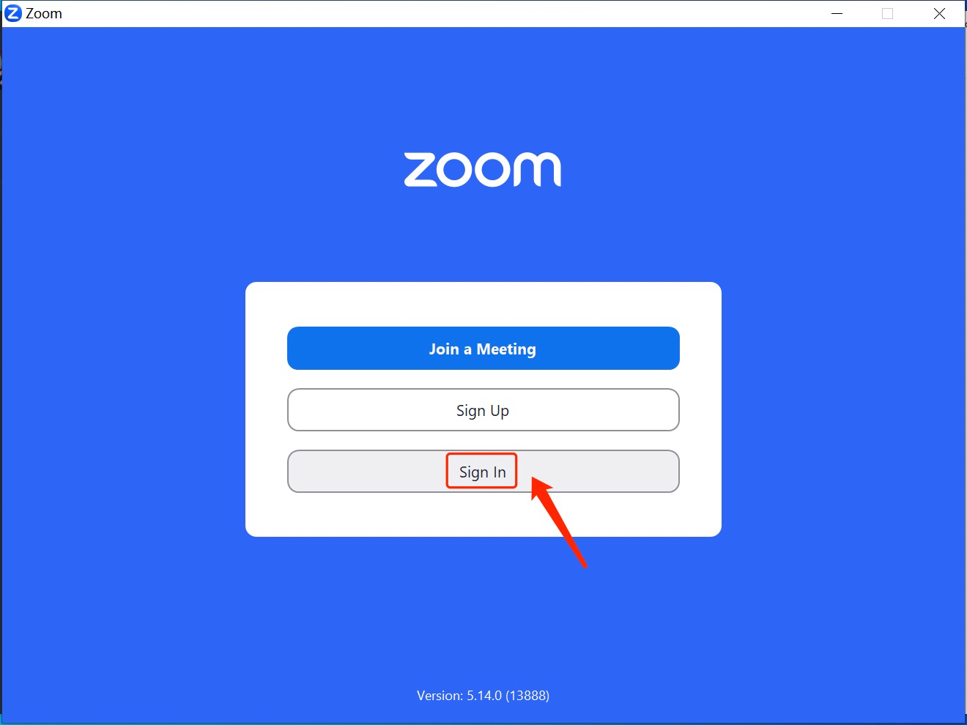

1. Sign in with your newly-created account.

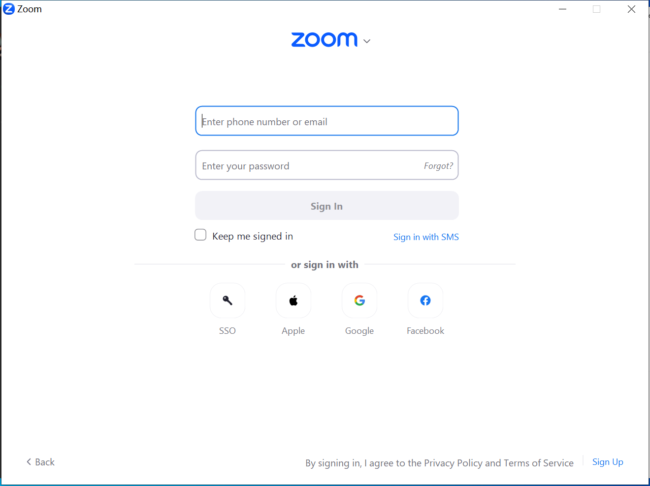

1. Enter your Meeting ID to join a meeting

