Attachment 3

**How** **to** **use** **WeChat**

WeChat is one of the most popular apps in China. Throughout the seminar, WeChat will be used as the instant communication tool between participants and seminar coordinator. Download the latest version of WeChat APP on your mobile phone. Open the WeChat app, tap “Sign Up” and “Sign up with mobile”, choose your region code, enter your mobile and set a password. One mobile phone number can only be used for creating one WeChat account.

**Step** **by** **Step** **Instructions**

*Step* *1*: *Download*

Either

1. Simply download WeChat from App Store by searching WeChat.

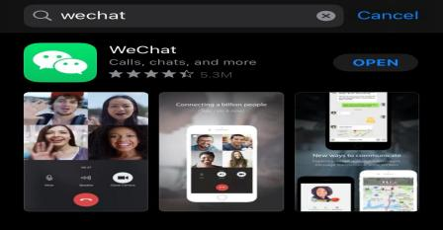

Or

2. Download WeChat via the following website

<http://www.wechat.com/en/>.



*Step2*: *SignUp*

1. Open WeChat, click “Sign Up,” and enter your phone number to get a text message with a verification code to complete the sign-up.

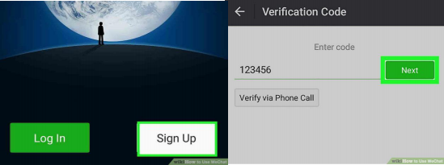

**\*** **If** **you** **don’t** **get** **a** **verification** **code,** **click** **No** **verification** **code** **received,** **and**

**then** **click** **“Resend”** **to** **get** **another** **text** **message,** **or** **click** **“Phone** **Call”** **to** **get** **an** **automated** **phone** **call** **with** **the** **verification** **code.**

*Step3: Add New Friends*

Click the “+” icon at the upper right corner, choose “Add Contacts” ,and search for people by phone number or WeChat ID, and add them to your

contacts.

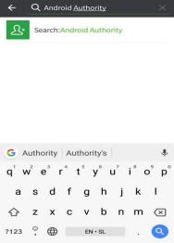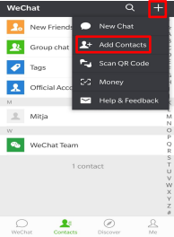

***Step*** ***4:*** ***Start*** ***a*** ***chat***

Go to “Contacts”, click the friend’s name, and select “Messages” or

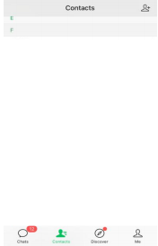“Voice or Video Call” to start a chat.

**\*If** **there** **is** **any** **problem** **during** **the** **use** **of** **the** **app,** **please** **refer** **to** **the** **following**

**link** **for** **specific** **solution:** [**https://help.wechat.com/oshelpcenter**](https://help.wechat.com/oshelpcenter)