Appendix 3
Instructions：How to Use WeChat
WeChat is one of the most popular apps in China. Throughout the seminar, WeChat will be used as the instant communication tool between participants and seminar coordinators. Download the latest version of WeChat APP on your mobile phone. Open the WeChat app, tap “Sign Up” and “Sign up with mobile”, choose your region code, enter your mobile number and set a password. One mobile phone number can only be used for creating one WeChat account.

Step-by-Step Instructions

Step 1: Download

Either
- Simply download WeChat from App Store by searching WeChat.

Or

2. Download WeChat via the following website

http://www.wechat.com/en/

Step 2: Sign up
- Open WeChat, click “Sign Up” and enter your phone number to get a text message with a verification code to complete the sign-up.

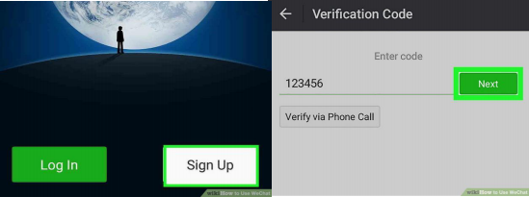

* If you don’t get a verification code, click “No verification code received”, and then click “Resend” to get another text message, or click “Phone Call” to get an automated phone call with the verification code.
Potential Problem 1:
When signing in with a WeChat account, it shows that “Contact a WeChat user” to verify the security check.
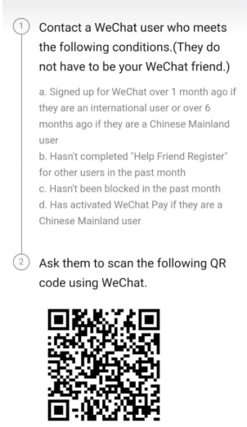
Solution 1:
1. Contact us via e-mail (personneltraining@bricspic.org), and our personnel will contact you through WhatsApp;
2. Send us this screenshot in WhatsApp, and we will help you scan the QR code.
Potential Problem 2:
Your local phone number is not accepted while trying to register a WeChat account.
Solution 2:
We recommend you to ask one of your friends who has a phone number of another data provider to register a WeChat account and give the account to you.

Step 3: Join the WeChat Group
1. Save the picture of our WeChat group into your album.
2. Click the “+” icon at the upper right corner.
3. Then click “Scan” in the pop-up.

4. Click “Album” and choose the QR code of our WeChat group in your album.
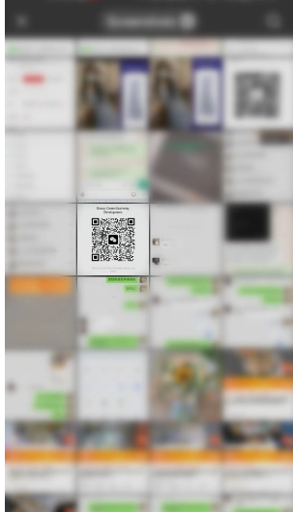
5. Click “Join Group Chat”

Step 4: Change Weixin ID

Please note that this step is necessary as our personnel couldn’t add you as a friend by searching your ID in WeChat if you don’t change your original one.
1. Click your profile photo on “Me” Page and then choose Weixin ID.
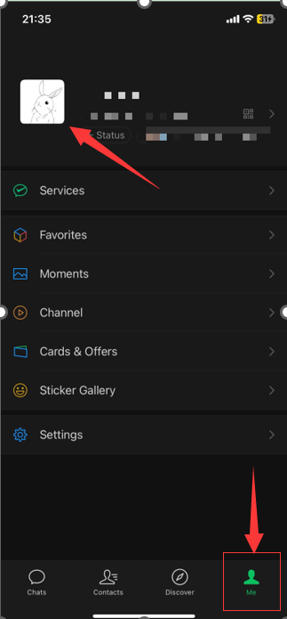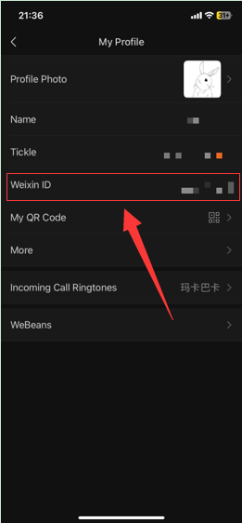

- Enter your WeChat password to verify your identity and then you can set a new Weixin ID.
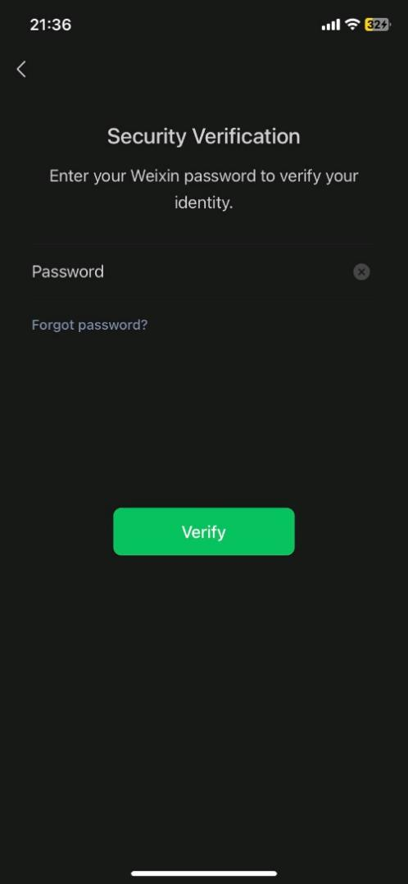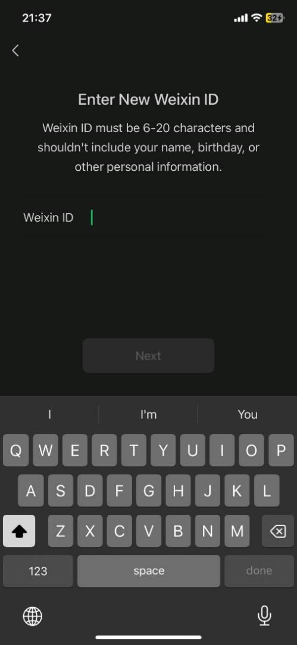

Step 5: Start a chat
Go to “Contacts”, click the friend’s name, and select “Messages” or “Voice or Video Call” to start a chat.

*If there is any problem during the use of the app, please refer to the following link for specific solutions: https://help.wechat.com/oshelpcenter or contact us via Email：personneltraining@bricspic.org.

